# Assignment-3

**Build CNN Model for Classification Of Flowers**

|  |  |  |
| --- | --- | --- |
| Assignment Date | : | 15 October 2022 |
| Student Name | : | Kiruthiga M |
| Student Roll Number | : | 212219040115 |
| Maximum Marks | : | 2 Marks |

**Task 1:**

**Question- 1:**

Download the dataset

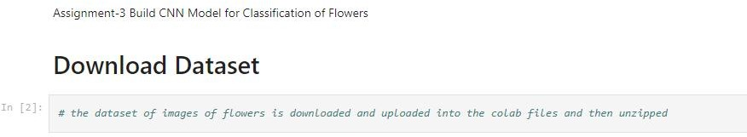

Solution:

import warnings warnings.filterwarnings('ignore')

from tensorflow.keras.models import Sequential from tensorflow.keras.layers import Dense

from tensorflow.keras.layers import Convolution2D from tensorflow.keras.layers import MaxPooling2D from tensorflow.keras.layers import Flatten

Output:

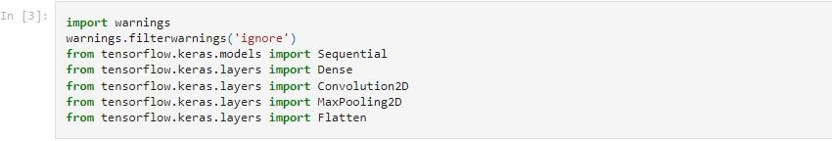

Solution:

from tensorflow.keras.preprocessing.image import ImageDataGenerator

Output:

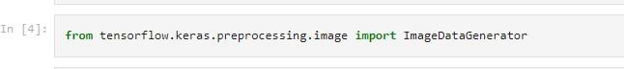

Solution:

!unzip '/content/Flowers-Dataset.zip' Output:

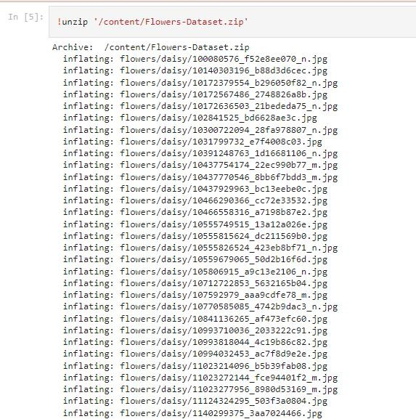

Task 2:

**Question- 2:**

Image Augmentation

Solution:

#Image Augmentation on training varaible train_datagen = ImageDataGenerator(rescale=1./255,

zoom_range=0.2, horizontal_flip=True)

Output:

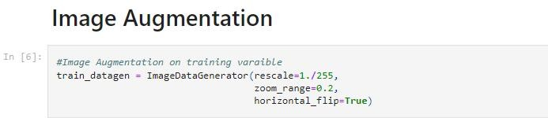

Solution:

#Image Augmentation on testing variable test_datagen = ImageDataGenerator(rescale=1./255)

Output:

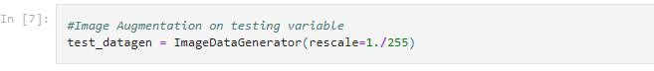

Solution:

### #Image Augmentation on training data

Xtrain=train_datagen.flow_from_directory('/content/ flowers',target_size=(64,64),class_mode='cate gorical',batch_size=100)

Output:

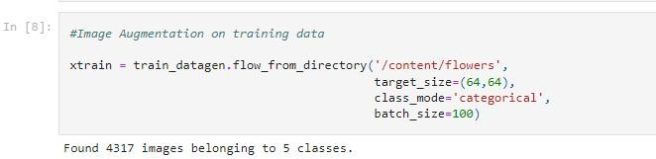

Solution:

### #Image Augmentation on training data

Xtrain=train_datagen.flow_from_directory('/content/ flowers',target_size=(64,64),class_mode='cate gorical',batch_size=100)

Output:



Solution:

xtrain.class_indices Output:

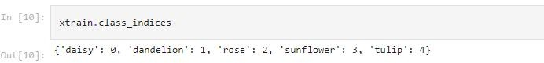

Task 3:

**Question- 3:**

Create Model

Solution:

### # Initializing sequential model

model = Sequential()

Output:

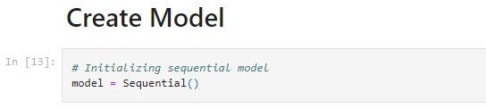

# Task 4:

**Question- 4:**

Add Layers

A .Convolution Layer

Solution:

model.add(Convolution2D(32,(3,3),activation='relu', input_shape=(64,64,3)))

Output:

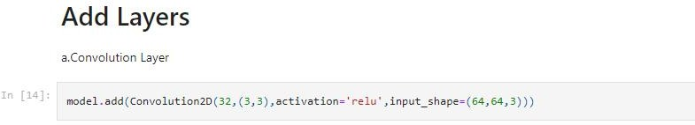

B .Max-Pooling Layer

Solution:

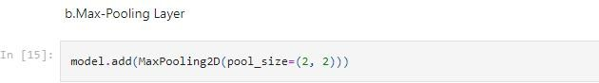model.add(MaxPooling2D(pool_size=(2, 2))) Output:

C .Flatten Layer

Solution:

model.add(Flatten()) Output:

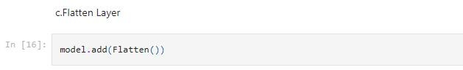

D .Hidden Layer

Solution:

model.add(Dense(300,activation='relu')) # Hidden layer 1 model.add(Dense(150,activation='relu')) # Hidden layer 2

Output:

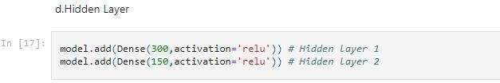

E .Output Layer

Solution:

### model.add(Dense(5,activation='softmax'))

Output:

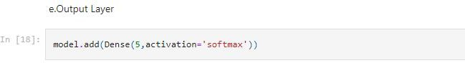

## Task 5:

**Question- 5:**

Add Layers

Solution:

### from tensorflow.keras.models import Sequential

Output:

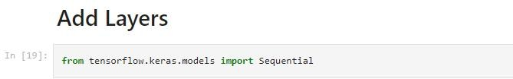

Solution:

### from tensorflow.keras.layers import Dense, Convolution2D, MaxPooling2D, Flatten

Output:

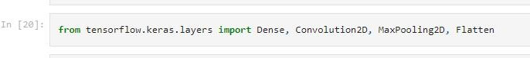

Solution:

### model = Sequential()

Output:



Solution:

### model.add(Convolution2D(32, (3,3), input_shape=(64,64,3), activation = 'relu'))

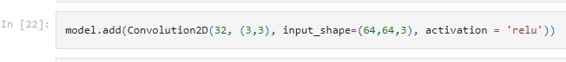Output:

Solution:

### model.add(MaxPooling2D(pool_size = (2,2)))

Output:



Solution:

### model.add(Flatten())

Output:



Solution:

model.summary()

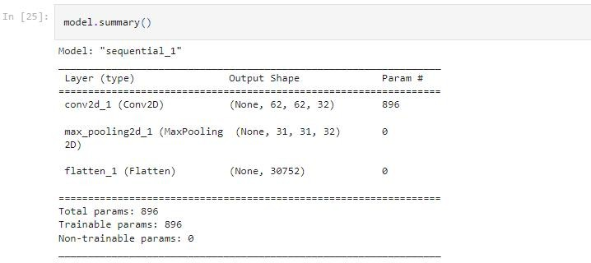

# Task 6:

**Question- 6:**

Compile the Model

Solution:

### model.compile(loss='categorical_crossentropy', optimizer'adam',metrics=['accuracy'])

Output:

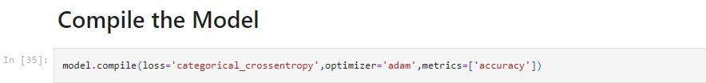

# Task 7:

**Question- 7:**

Fit the Model

Solution:

model.fit_generator(xtrain,steps_per_epoch=len(xtrain), epochs=10,validation_data=xtest,validation_steps=len (xtest)))

Output:

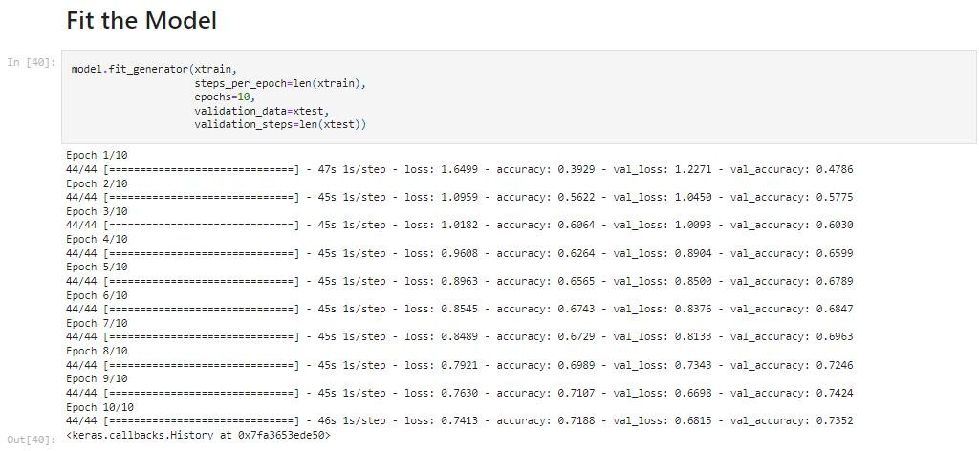

# Task 8:

**Question- 8:**

Save the Model

Solution:

### model.save('CNN_Flowers.h5')

Output:

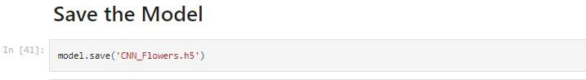

Solution:

ls Output:

# Task 9:

**Question- 9:**

Test the Model

Solution:

### from tensorflow.keras.models import load_model from tensorflow.keras.preprocessing import image import numpy as np

Output:

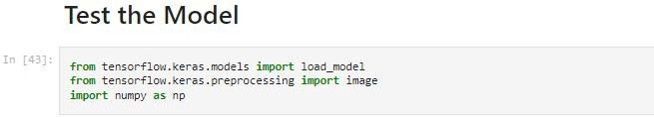

Solution:

### import numpy as np

from tensorflow.keras.models import load_model

Output:

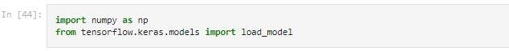

Solution:

from tensorflow.keras.preprocessing import image Output:



Solution:

### model=load_model('CNN_Flowers.h5')

Output:



Solution:

### pwd

Output:

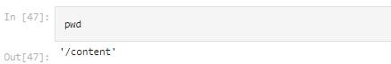

Solution:

### img = image.load_img('/content/flowers/rose/1233 8444334_72fcc2fc58_m.jpg')

Output:



Solution:

### Img

Output:

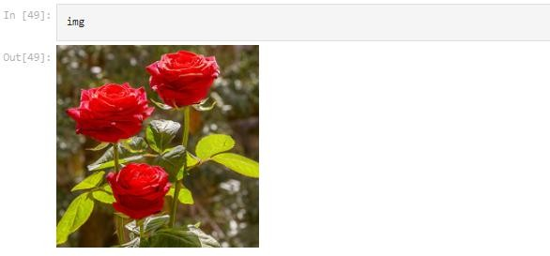

Solution:

### img =

image.load_img('/content/flowers/dandelion/ 14003401241_543535b385.jpg',target_size=(64, 64))

Output:

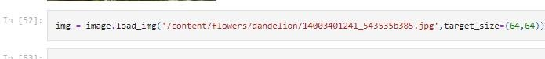

Solution:

### Img

Output:

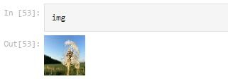

Solution:

### x=image.img_to_array(img)

Output:



Solution:

### X

Output:

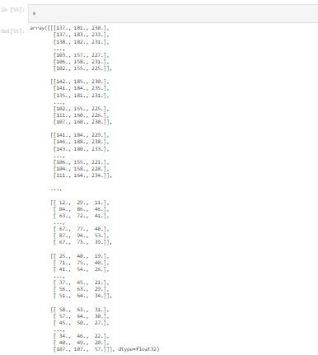

Solution:

### x.shape

Output:

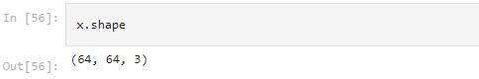

Solution:

### x=np.expand_dims(x,axis=0)

Output:



Solution:

X

Output:

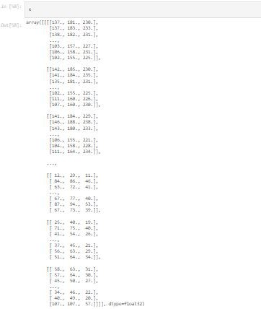

Solution:

### x.shape

Output:

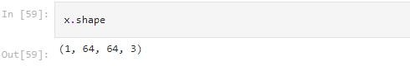

Solution:

### xtrain.class_indices

Output:



Solution:

index=["Daisy","Dandelion","Rose","Sunflower","Tulip"] Output:



Solution:

### index[0]

Output:

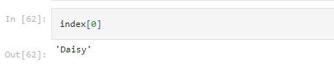

Solution:

### img = image.load_img('/content/flowers/sunflower/151 45607875_e87204d78c_n.jpg',target_size=(64,64))

Output:

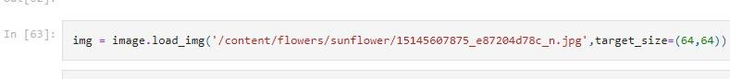

Solution:

### img

Output:

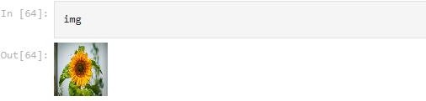

Solution:

### xtrain.class_indices

Output:

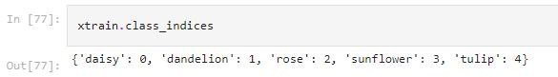

Solution:

op = ['daisy','dandelion','rose','sunflower','tulip'] pred = np.argmax(model.predict(x))

op[pred] Output:

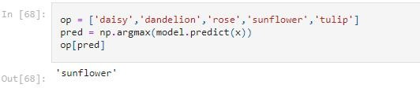

Solution:

dandelion =

image.load_img('/content/flowers/dandelion/1356015 2823_9da5e48c87_m.jpg',target_size=(64,64))

x = image.img_to_array(dandelion) x = np.expand_dims(x,axis=0)

pred = np.argmax(model.predict(x)) op[pred]

Output:

